Lesson07: Lab Exercises – Data Passing to/from Functions

AIMS
To gain experience programming using the C language, with emphasis: on functions and control structures.
Objectives
When you have completed these exercises, you should be able to: • Pass data by value to a function; • Return data from a function.

Exercise 1 – Return data from a function
Read Lesson6-7 of your lecture notes page 9. Consider the example program which calls a function called getNumber(). This function asks the user to input a number and then returns this number to the calling function. Note: a function can only return ONE value to the calling function.
#include <stdio.h>

/* Function prototype. */
int getNumber(void);

int main()
{

int x = 0;

/* call function to fetch user input, return value assigned to x */

x = getNumber();

printf("x = %d\n", x);

return 0;

}
/* Function Definition */
int getNumber(void)

{
/* data declaration – one local variable */
int number;

/* ask user to enter a number */
printf("please enter a number > ");

/* Read in number from input to memory */
scanf("%d", &number);

/* return number */
return number;
}

Write a program lab7ex1.c based on your lab6ex3.c draw rectangle program but should include a function for user input:
The main function:
1) Calls get_size function and assigns the returned size value to an integer variable 2) Calls draw_rectangle function passing this function the size value.

The get_size function
- Calls printf function to asks the user to input the size of the rectangle
- Calls the scanf function to read in the size and store in an integer variable 3. Returns the size value to the calling function
The draw_rectangle function (from lab6ex3.c) will draw a rectangle using the * symbol with the horizontal side double the size of the vertical side.

Compile, link and execute the program.
Code: Log your code and run attempt here >>
#include <stdio.h>

/* Function prototypes */
void display_line(int num_of_stars);
int get_size(void);
void draw_rectangle(int num_of_rows, int num_of_stars);

int main()
{
int size = 0;

/* Call get_size function and assign the returned size value to a variable */
size = get_size();

/* Call draw_rectangle function passing the size value */
draw_rectangle(size, size * 2);

return 0;
}

/* Function to get the size of the rectangle from the user */
int get_size(void)
{
int size;

/* Ask the user to input the size of the rectangle */
printf("Please enter the size of the rectangle: ");

/* Read in the size from the user */
scanf("%d", &size);

/* Return the size value */
return size;
}

/* Function to draw a rectangle */
void draw_rectangle(int num_of_rows, int num_of_stars)
{
int i;

/* Draw the top side of the rectangle */
for (i = 0; i < num_of_rows; i++) {
display_line(num_of_stars);
}
}

void display_line(int num_of_stars)
{
int i;
for (i = 0; i < num_of_stars; i++) {
printf("*");
}
printf("\n");
}

Test Results >> (screen captures)
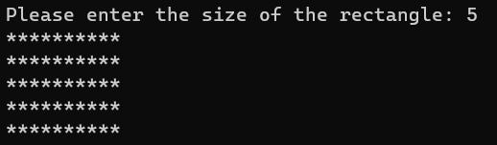

Comment on your Results – what were key learning points
Function prototypes
Fuction definitions
User input
Fuction calls

Exercise 2 – Modular Program
Main Program
printHello
display
compute
void
void
float
val
float
result
float
val
f
loat result
void

Figure 1: Block Diagram
Create a new program lab7ex2.c that computes the value of:
..
5
1
+
=
val
resu
lt
The program should contain the following functions:
1. The printfHello function prints a brief welcome message to the user of the program 2. The compute function computes the following equation:
result =
5
1
+
val
- The display function prints out the value of val and the result value.

- The main function calls the other functions to compute and display the result for val = 0.5,1, 1.5, 2, … 10, displayed to 5 decimal places of accuracy. For example:
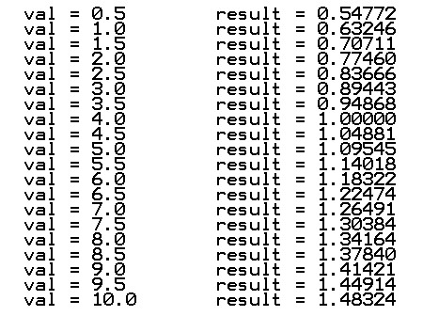
Compile, link and execute the program.
Code: Log your code and run attempt here >>
#include <stdio.h>

/* Function prototypes */
void printfHello(void);
double compute(double val);
void display(double val, double result);

int main()
{
double val;
double result;

/* Call printfHello function */
printfHello();

/* Compute and display the result for val = 0.5, 1, 1.5, 2, ..., 10 */
for (val = 0.5; val <= 10; val += 0.5)
{
result = compute(val);
display(val, result);
}

return 0;
}

/* Function to print a welcome message */
void printfHello(void)
{
printf("Welcome to the equation computation program!\n");
}

/* Function to compute the equation */
double compute(double val)
{
double result;

result = 1 + (1 / val);

return result;
}

/* Function to display the value of val and the result */
void display(double val, double result)
{
printf("For val = %.5lf, the result is %.5lf\n", val, result);
}

Test Results >> (screen captures)
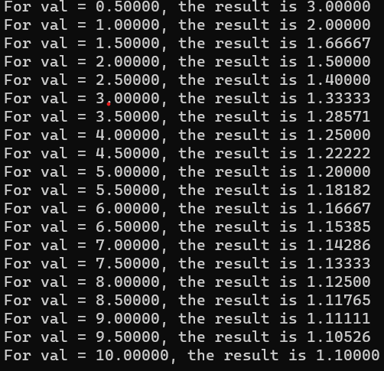
Comment on your Results – what were key learning points

Exercise 3 – Computing Highest, Lowest and Average
Create a modular program lab7ex3.c that reads in three integer values and computes and displays:
- the average value;
- the highest value;
- the lowest value;
- how many of the numbers are greater than the average value.

(Think about how this might be done if there were 100 integers)

Compile, link and execute the program.
Code: Log your code and run attempt here >>
#include <stdio.h>

/* Function prototypes */
int get_input(void);
float calculate_average(int num1, int num2, int num3);
int find_highest(int num1, int num2, int num3);
int find_lowest(int num1, int num2, int num3);
int count_greater_than_average(int num1, int num2, int num3, float average);

int main()
{
int num1, num2, num3;
float average;
int highest, lowest;
int count;

/* Call get_input function to get three integer values */
num1 = get_input();
num2 = get_input();
num3 = get_input();

/* Call calculate_average function to calculate the average value */
average = calculate_average(num1, num2, num3);

/* Call find_highest function to find the highest value */
highest = find_highest(num1, num2, num3);

/* Call find_lowest function to find the lowest value */
lowest = find_lowest(num1, num2, num3);

/* Call count_greater_than_average function to count how many numbers are greater than the average value */
count = count_greater_than_average(num1, num2, num3, average);

/* Display the results */
printf("Average value: %.2f\n", average);
printf("Highest value: %d\n", highest);
printf("Lowest value: %d\n", lowest);
printf("Number of values greater than average: %d\n", count);

return 0;
}

/* Function to get input from user */
int get_input(void)
{
int num;

/* Ask user to input a number */
printf("Please enter a number: ");

/* Read in the number from user */
scanf("%d", &num);

/* Return the number */
return num;
}

/* Function to calculate the average value */
float calculate_average(int num1, int num2, int num3)
{
float average;

/* Calculate the average value */
average = (num1 + num2 + num3) / 3.0;

/* Return the average value */
return average;
}

/* Function to find the highest value */
int find_highest(int num1, int num2, int num3)
{
int highest;

/* Find the highest value */
highest = num1;
if (num2 > highest)
{
highest = num2;
}
if (num3 > highest)
{
highest = num3;
}

/* Return the highest value */
return highest;
}

/* Function to find the lowest value */
int find_lowest(int num1, int num2, int num3)
{
int lowest;

/* Find the lowest value */
lowest = num1;
if (num2 < lowest)
{
lowest = num2;
}
if (num3 < lowest)
{
lowest = num3;
}

/* Return the lowest value */
return lowest;
}

/* Function to count how many numbers are greater than the average value */
int count_greater_than_average(int num1, int num2, int num3, float average)
{
int count = 0;

/* Check if each number is greater than the average value */
if (num1 > average)
{
count++;
}
if (num2 > average)
{
count++;
}
if (num3 > average)
{
count++;
}

/* Return the count */
return count;
}

Test Results >> (screen captures)
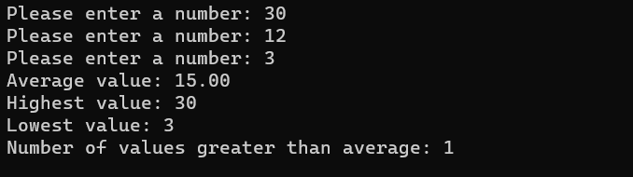
Comment on your Results – what were key learning points

Additional Optional Practice Exercises: Writing Functions
Read Lesson6-7 lecture notes page 10 to 16 and attempt the following exercises.
- Write a C program using functions to calculate the cube of a number. The program shall ask the user to input a number, where the value should be an integer value in the range 1 to 1000. Then the program shall calculate the cube of the number. Finally the program shall display the result.

- Write a C function that calculates the area of a circle, where the function is passed the value of the radius and returns the calculated area ((area = πr2). The function should use a constant for the value of π. Add at least one comment to the code.

- A function is required to implement the division of two whole numbers. The input parameters for the function are two integer values. The function performs one operation, the floating point division of the two input values. The return value from the function is a single precision floating point number.

